**Healing Website Testing Report**

* **Login/Register Buttons do not work and have values set to null**

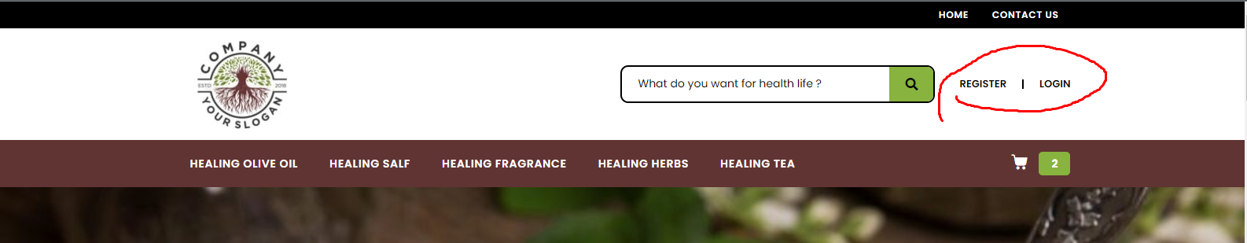

* **All of the marked buttons in the below screenshot work fine**

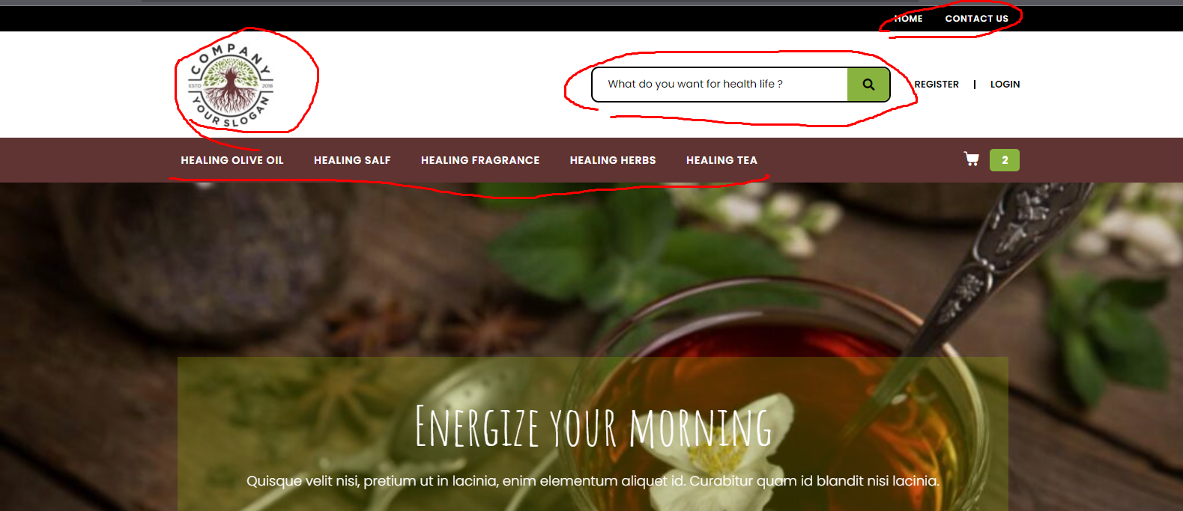

* **Review section/ commenting works fine**

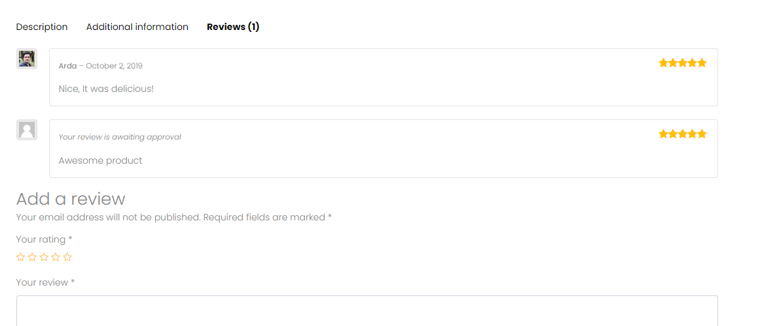

* **The buttons in the footer section works fine**

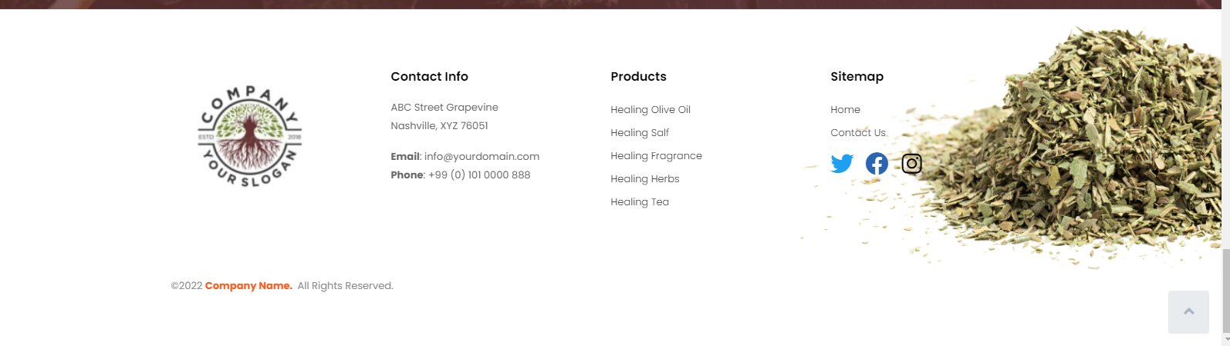

* **The buttons on these ads don’t work**

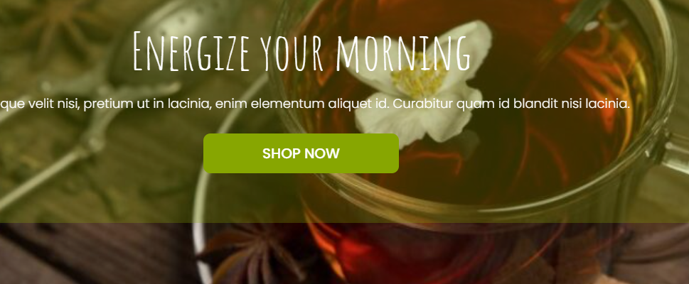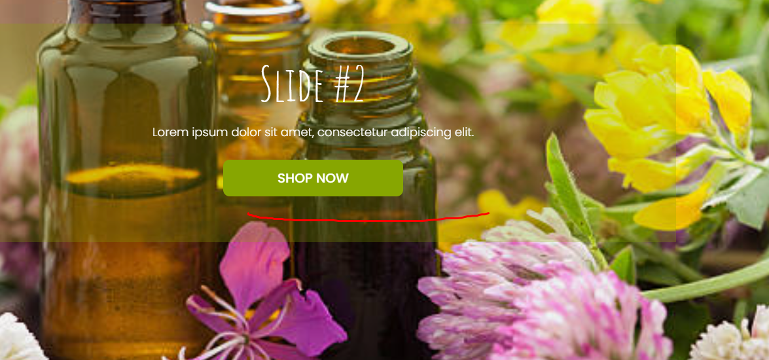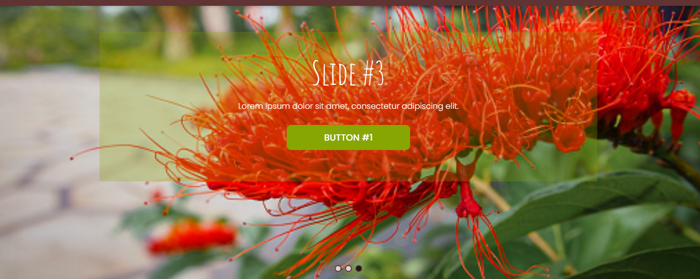

* **Why about us heading has jibrish content**

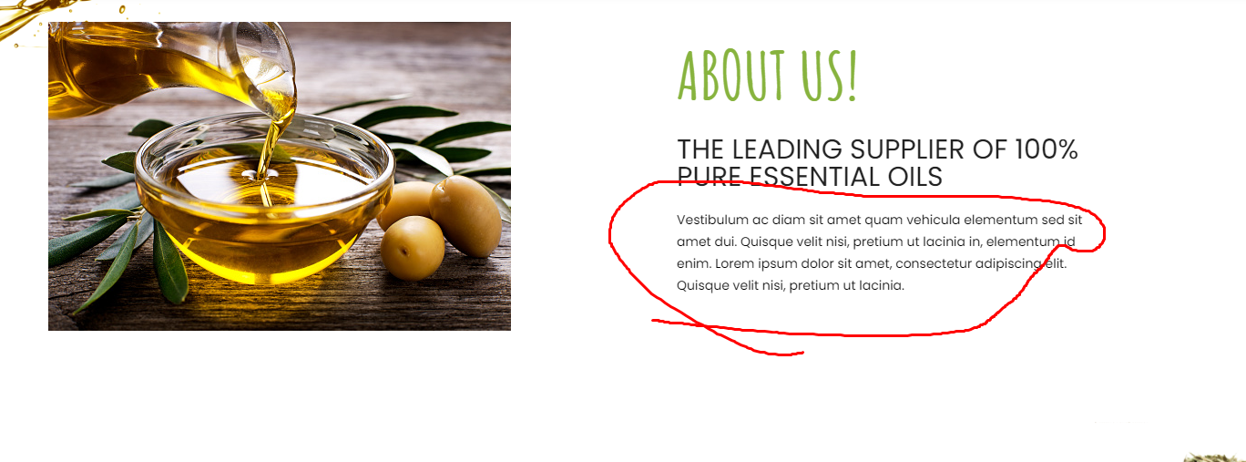

* **Why Partners Section has no company names only repetition of *Company Name\***

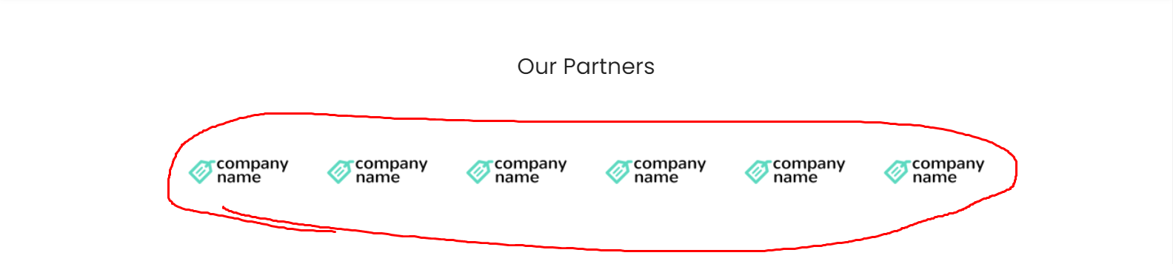

* **There should be a Home Button next to the logo or next to the register/login buttons**

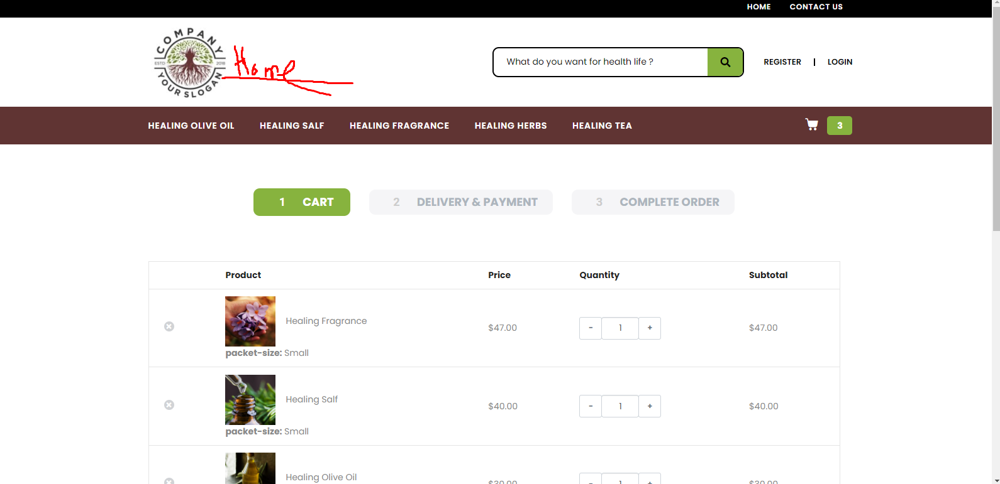

* **View cart and complete checkout process works fine except for the payment section where there is no payment method**

